Lab 09b - Implement Azure Container Instances

In this lab, we have the following tasks :

* Task 1: Deploy a Docker image by using the Azure Container Instance
* Task 2: Review the functionality of the Azure Container Instance

#### Task 1: Deploy a Docker image by using the Azure Container Instance

First a container instance is created with the following settings:

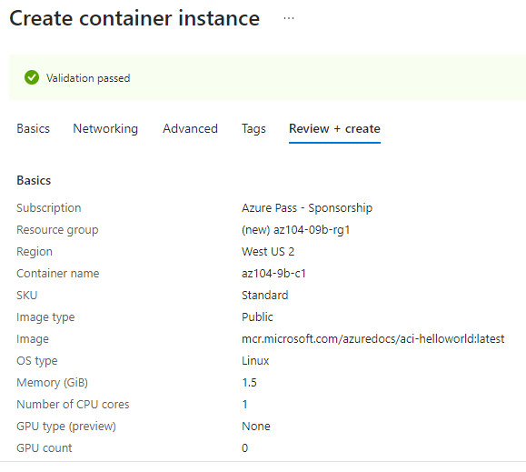

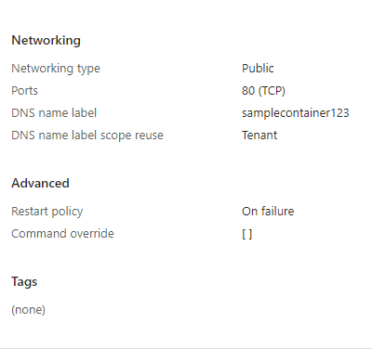

#### Task 2: Review the functionality of the Azure Container Instance

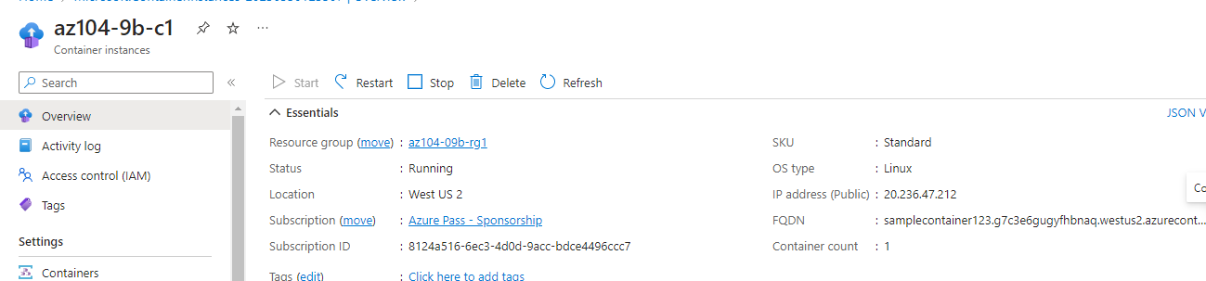

If we open the **FQDN (**fully qualified domain name (FQDN) represents a domain name of a host or IP address**) link in a new tab we will see this page:**

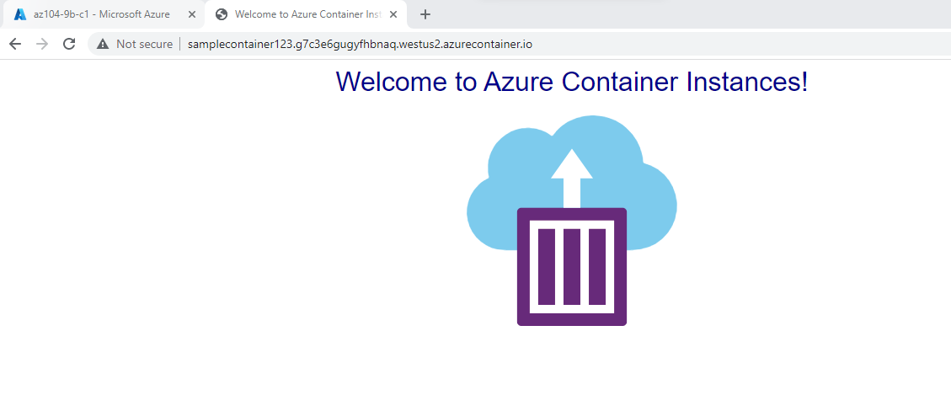

In the **Settings** section of the container instance blade, when we click **Containers**, and then **Logs** we can see the log entries representing the HTTP GET request generated by displaying the application in the browser.

